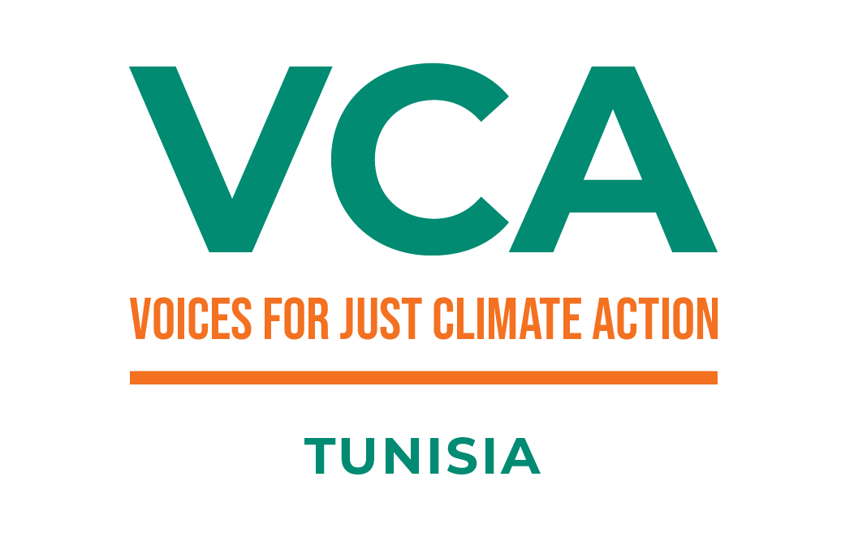
Voices for Just Climate Action (VCA) Programme

Next Level Grant Facility (NLGF) Call:
Terms of Reference (ToR)

- Context:

The Voices for Just Climate Action (VCA) Programme
The Voices for Climate Action (VCA) programme is a lobby and advocacy programme being implemented in seven countries by the World-Wide Fund for Nature (WWF) Netherlands, SouthSouthNorth (SSN), Akina Mama wa Afrika (AMwA), Slum Dwellers International (SDI), Fundación Avina and Hivos under the Dutch Ministry of Foreign Affairs’ five-year strategic partnership: “Power of Voices”. This programme is being implemented in Tunisia by the VCA alliance: AMwA, SSN, Hivos and WWF North Africa (WWF NA).
The Voices for Climate Action (VCA) in Tunisia aims to ensure that by 2024, local civil society and marginalized groups will have taken on a central role as creators, facilitators and advocates of innovative and inclusive climate solutions. VCA supports locally shaped climate solutions through an inclusive and rights-based approach. The programme intends to see an expanded civic space where civil society voices, in particular those of vulnerable and/or marginalized people are heard on climate action.
Background
Current financing systems are not designed to support small, informal groups and organizations efficiently. These groups often cannot meet the bureaucratic requirements set by donors, international funds and financial institutions.
The Next Level Grant Facility (NLGF) is a financing tool created within the framework of the VCA program. The NLGF aims to foster a bottom-up approach to decision-making, where local communities play a key role in identifying priorities and defining solutions. The facility is implemented by contracted local partners in the seven implementing countries of the VCA. These organizations work to expand civic space and work on the inclusion of voices of vulnerable and marginalized groups.
- Objective
NLGF's primary objectives
The NLGF objective is to support emergency situations, unforeseen activities or opportunities that contribute to VCA project aspirations.
Examples :
- Support small organizations to attend any urgent meeting with the government and business leaders from private sector, legal advice for communities affected by land conflicts, protection of persecuted environmental activists, financing of campaigns, assistance to populations affected by natural disasters or financing studies to generate evidence that supports specific positions.
- Support for communication campaigns on emerging and current issues that help increase visibility and amplify the voices of local populations and groups that are most vulnerable to climate change.
- Support for the production of communication materials for traditional media and social networks.
- Legal advice for communities affected by land conflicts (related to harmful projects), protection of persecuted environmental activists,
- Assistance to populations affected by natural disasters
- Financing studies to generate scientific evidence that supports specific positions particularly urgent climate related issues that require a rapid response.
- Rapid response for the security of human rights defenders and environmental defenders.
III- Scope of the call
Call for proposal
WWF North Africa as a VCA Alliance partner is coordinating the Next Level Grant Facility (NLGF) in Tunisia. WWF NA is seeking a Local partner – Fund manager for NLGF to manage the funds and processes, including - scoping for emergencies, pre-selection and assessment in consultation with the alliance, regranting to small organizations and individuals (management, administration, monitoring, and reporting) on the grant as needed.
The Fund Manager have to fulfill the following tasks:
- Establish and coordinate a transparent application process for NLGF funds, in consultation with the VCA alliance.
- Develop effective and appropriate communication to disseminate NLGF availability to direct beneficiaries.
- Establish a methodology for evaluating and deciding on proposals received.
- Establish and coordinate application selection processes in consultation with the VCA alliance.
- Evaluation of all NLGF applications.
- Establish and conduct due diligence to ensure applicant eligibility and ability to comply (in practice, this may be based on an analysis of the context, previous experience of some project partners or references), in order to ensure a justified choice and avoid misuse of funds and favoritism.
- Communicate with applicants throughout the application process to ensure that applicants are informed and fully understand the process.
- Manage the disbursement of funds to beneficiaries, where applicable.
- Make payments for services, procurement and logistical support.
- Monitor, track and document technical and financial performance of grantees.
- Compile technical and financial documentation of support provided to beneficiaries through monthly reports
- Provide technical and financial support to grantees,
- Working closely with grantees during implementation period
- Report on the status of the NLGF account throughout the project.
- Periodic evaluation of the fund, with the VCA alliance. and other actors linked to the VCA project, in order to learn lessons and carry out adaptive management.

Grant Details
The Grant manager contract duration is for 08 months: (From January 2024 to August 2024)
Please note That:
- The call for subgrantees have to be lunched in mid- January 2024;
- July is the deadline for finalizing Subgrantees activities;
- In August all final subgrantees reports have to be shared with the Fund manager;
- In September final subgrantees reports and fund manager report have to be shared with WWF NA and VCA alliance.
The total contract amount is 134,500 Euro which breaks down as follows:
- Total Budget dedicated to Grant Manager: 28 000 Euros (including Direct and indirect cost)
- Total amount to be granted: 106,500 Euros
Please note that the total grant per grant recipients must not exceed Euro 10,000 Euros the NLGF fund will run for five months maximum with a total amount of 106,500 Euros

Beneficiaries of NLGF
The beneficiaries of the NLGF have to be:
1) Small informal organizations that do not have the capacity to apply and report on more formal grants but that represent local right holders and work on local climate solutions. Initial guidance on ”small” is organizations with yearly cash flow below 100,000 EUR/yr and with only few (partly) paid staff members.
2) Individuals: NLGF will also fund individuals. Climate activists, journalists, local climate champions are not always acting on behalf of a (formal) organization, while threats to these individuals can be very serious.

V- Evaluation methodology
Who is Eligible to Apply?
The call is open to organizations / NGOs that must:
- Be legally registered in Tunisia
- Have a minimum of five years of existence and operation
- Have a strong record of upholding human rights
- Be operating at national and/or country level.
- Have prior experience carrying out activities related to climate change
- Have a proven track record in subgrant management, preferably with experience in similar funding mechanisms
- Have a track record on grant management and provide references of former similar experiences particularly strong procedures and rules in managing informal groups & individuals granting

VI- Application and timeline
Selection Criteria
-Application is submitted within the Deadline
-Evaluation of the Fund Manager’s team profile, stability and ability to implement the Next Level grant Facility
-Proven experience of working with Tunisian associations across the country
-Demonstration of ability to work as fund manager for similar fund dedicated to small groups, organizations/ONG and individuals with a total budget at least 100 000 Euros
-Demonstration of ability to collaborate with other actors to influence stronger impacts and jointly develop and implement a capacity strengthening plan for grant recipients

How to Apply:
Send a proposal of maximum 10 pages detailing the following;
- Organization background and structure (1 page)
- Detailed history and experience in managing similar grants of the Organization/NGO (2 pages)
- A list of anticipated risks and mitigation measures (maximum 1 page)
- Technical proposal describing the methodology and the approach of managing grants (for emergency actions, climate actions, informal groups) and including the general financial management scheme of grants (maximum 3 pages)
- Team profile, detailing who would be full-time dedicated to the fund and who would be part-time (with % dedication) (1 page)
- At least 3 References in project implementation (maximum 2 pages)
Requested Document
-Relevant team members’ CVs (outlining main academic, professional and other relevant experience)
-Detailed budget (Please use the Proposal financial Template)
-National Register of Companies - RNE/Minutes of a Meeting of the nomination of the current president
-The three most recent financial statements approved by the general meeting
-Purchasing Process of the organization

Timeline
Date | Item
Novembre 02, 2023 | Issuance of ‘Call for Proposals’
Decembre 10, 2023 | Deadline for submission of Proposals
December 11 – 18 December, 2023 | Evaluation of Proposals
19 December, 2023 | Pre-Selected applicant is notified
19 December ,2023– December 22, 2023 (tentative timelines) | -Due diligence, including operational and financial management, integrity and governance is conducted  - Possible interview with the Preselected applicant  -Successful applicant is notified.
December 28, 2024 | Signing of contract

Please submit your technical proposal and requested documents detailed in TOR before December 10, 2023 and send it to the following address: procurment@wwfna.org Mention” VCA- Call for NLGF Grant manager”

