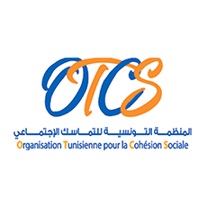
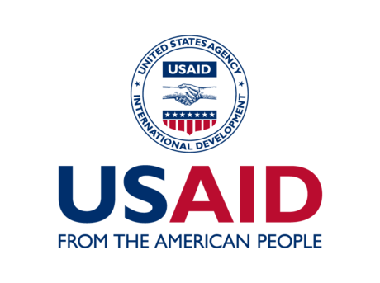 |  | 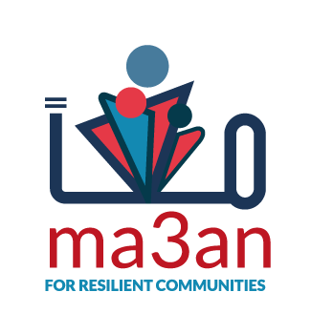
TERMS OF REFERENCE

Content Creation Agency-Consultant

“CREATE” Project

March 2022
- Assignment:
- Name of contracting organization: | Tunisian Organization For Social Cohesion (OTCS)
- Address for submitting proposals: | otcs.contact@gmail.com
- Closing Date & Time for submission of proposals: | May 18, 2022
- Bid Description: | Content creation agency-consultant for the CREATE project.

GENERAL CONTEXT:

Who we are:
The Tunisian Organization for Social Cohesion (OTCS) is a Tunisian civil society organization established in 2016. The OTCS works to promote a culture of dialogue through a better knowledge of the dynamics and factors of instability impacting social cohesion and capacity building of institutional actors and civil society in facilitation and regulation. Since its creation, the OTCS has worked mainly on the prevention of violent extremism through:
- The role played by the family and the educational family, the role played by women leaders living in rural areas, the rehabilitation of ex-prisoners, etc.
- The promotion of better inclusion of young people.
- Improving the relationship between law enforcement and citizens through security sector reform projects.
- Developing a network of facilitators for dialogue and consensus.

Project Presentation:
The project "Prevention of Violent Extremism Through Community Youth Engagement and Local Ownership of the National Strategy to Countering Terrorism and Extremism" (CREATE) is a pilot initiative to be launched by the Tunisian Organization for Social Cohesion (OTCS)-Rehab Ciollective as part of the national APS launched by the USAID-funded FHI-Ma3an Project. The "CREATE" project was developed based on a new concept that considers creative youth engagement and local ownership of the elements of the national counter-terrorism and counter-extremism strategy as a new innovative tool in the field of prevention of violent extremism.
The project will target 9 municipalities (Regueb, Degache, Nebr, Chorban, Kondar, Hammam-Lif, Dhehiba, Benguerdane, Gaafour) and will directly affect a total number of 450 youth.
The project will involve:
- The youth in a holistic process of capacity building in youth positive development, transformation and positive engagement with local institutions framed by the production of creative engagement content,
- The target Municipalities in a new kind of local policy that relates to the prevention of violence and violent extremism, and the local implementation of the national strategy of countering terrorism and extremism,
- The National Commission for Countering Terrorism (CNLCT) in a new perspective of implementation of the strategy which will involve this time the municipalities in the national effort of the fight against terrorism and the prevention of violent extremism,
- The National Federation of Tunisian Municipalities (FNCT) in a new experience with the national authorities responsible for the prevention of violent extremism.
- Local associations for a new commitment to the prevention of violent extremism.
Through this process that will engage these two different but complementary dynamics (youth-municipalities), the project will try to validate the following theory of change:
If young people with extreme vulnerability in cities that also present variables of marginalization and vulnerabilities, are well trained, equipped, engaged in creative processes that they themselves develop in collaboration with the different local institutions and more specifically the municipalities, and,
If the latter become closer to the national logic of the fight and prevention against terrorism and violent extremism and appropriate these main pillars, and
If the municipalities manage to involve youth and support their community engagement plans,
Then, these two positive vectors-dynamics will become capable of giving rise to a new tool for the prevention of, violent extremism at the local level with the guarantee, on the one hand, of the involvement of young people in a positive way and, on the other hand, of the approval at the local level of a new role for the cities that would be the prevention of violent extremism through local policies that are more inclusive and sensitive to the different dynamics of young people and of society.

Purpose:
The Content Creation Agency or the consuletant will be responsible for supporting the project’s Communication and Outreach Manager in the media coverage of all the project activities.

Target audiences:
- Youth on online communities on different platforms 18‐34 years.
- Local CSOs in the 9 target communities.
- 9 municipalities and national institutional
- Local Businesses in the 9 target communities.

Scope of Work:
- Development of new content (based on the strategy given by the Communication Manager) and adaption of provided content into different digital formats.
- Editing content as needed and as per Communication Manager requirements.
- Development of digital and multimedia content (script and production) that might require animation or human elements in the form of videos, animated captions, stories, GIFs, etc.
- Development of user‐generated content (polls ideas, simple surveys, interactive Instagram stories, interactive social media posts).
- Graphic design of all the contents-logos… related to the project.

GEOGRAPHICAL COVERAGE
The Content Creation Agency or consultant needs to cover the following communities:
Gaafour, Siliana; Nebr, El Kef; Hammam-Lif, Greater Tunis Area; Kondar, Sousse; Dh’hiba, Tataouine; Chorbane, Mahdia; Regueb, Sid Bouzid; Degache, Tozeur; Ben Guerdane, Medenine.

KEY TASKS, DELIVERABLES, and TIMELINES:

QUARTER | KEY TASKS | DELIVERABLES | TIMELINE
1 | Develop a CREATE visual identity while respecting the communication strategy and the Ma3An/Usaid charter  Decline this identity on different media and goodies : | -print, poster  -social media page -tot bag, pins, bob, recyclable pencil and notebook, stickers… | 22 Mai 2022
2 | Develop creative content with reference to the project's communication strategy, and set up a publication calendar relating to events, for large-scale dissemination of the project. | - Content (photo, vidéo, graph)  - Content plan.  - Events calendar | 30 Mai 2022
 | Create content to simplify the Finding of the action-oriented social research | Graphs/Poster  Videos | 5 June 2022
 | Media coverage for the validation workshops | Photos  Videos | 15 June 2022
 | Interviews with some of the selected participants/Guests | Videos | 15 June 2022
3 | Content for the outreach campaign of the YPDCs | Photos  Videos | 30 July 2022
 | Media coverage for the YPDCs- shooting videos and taking pictures of the YPDCs training and artistic activities | Photos  Videos  Live sessions on Facebook | 30 August 2022
4 | Media coverage Youth Resilience Discovery session | Photos  Videos | 30 October 2022
 | Media coverage for the PVE local dialogues | Photos  Videos | 30 November 2022
5 | CRC Brand design | Brand Kit for the CRCs | 30 November 2022
 | Media Coverage for Communal resilience committees | Photos  Videos | 30 December 2022
 | Content simplifying the CEPs in each community | Images  Videos | 25 February 2023
6 | Media coverage youth-led activities | Photos  Videos | 30 April 2023
 | Media coverage for the closing ceremony | Photos  Videos | 15 May 2023

ELIGIBILITY CRITERIA
Organizations who are registered in Tunisia as companies or consultants with the following background and experience will be eligible.

Qualifications of the Organization or the individuals:
- Organizations or individuals with substantive work portfolios in creative advertising and communication –tradition, digital and new-age alternatives, documentary film making in both rural and urban geographies.
- Have at least 2-5 years of experience in undertaking media communications and outreach at scale, in particular to marginalized sections of the society.
- A demonstrative network in the media sector, think tanks, and other civil society organizations are preferred.
- Prior experience of undertaking a similar project or can partner with an agency with the relevant experience.

PROPOSED PAYMENT SCHEDULE
- The contract shall be for fifteen (15) months, to commence upon the validation of the Content Strategy by the project manager and the project’s communication manager.
- The approved budget of the contract for the project is thirteen thousand seven hundred Tunisian Dinars (TND 13,700.00) inclusive of all applicable taxes, agency service fees, bank charges, and other fees as may be incurred in the process.
- The proposed payment scheme for the campaign will be billed progressively upon completion of the following milestones:
MILESTONES | % OF PAYMENT
Submission of approved Content Strategy. | 10%
Submission of approved rollout report of implemented content plan and strategy on the May-July period | 10%
Submission of approved rollout report of the implemented content plan and strategy on August period | 20%
Submission of approved rollout report of the implemented content plan and strategy on September-November period | 20%
Submission of approved rollout report of the implemented content plan and strategy on December-February period | 20%
Submission of rollout report of the implemented content plan and strategy on March-May period | 10%
Submission of the final rollout report of the implemented content plan and strategy. | 10%

EVALUATION CRITERIA

C. NO. | DESCRIPTION | POINTS
Section 1. Vendor’s qualification, capacity, and experience
1.1 | Officially registered legal entity with a valid registration or individual working as freelancers: a portfolio is strongly requested. | 10
1.2 | Extent to which any work would be subcontracted (subcontracting carries additional risks  which may affect delivery, but properly done it offers a chance to access specialized skills.) | 10
1.3 | Qualifications of the candidates:  Organizations OR consultants with substantive work portfolios in creative advertising and communication –tradition, digital and new-age alternatives, documentary film making in both rural and urban geographies.  Have at least 2-5 years of experience in undertaking media communications and outreach at scale, in particular to marginalized sections of the society, and in the creation of the graphic identity.  A demonstrative network in the media sector, think tanks, and other civil society organizations are preferred.  Prior experience of undertaking a similar project or can partner with an agency with the relevant experience. | 10
Section 2. Proposed Content Strategy and Content Plan
 | Ability to create a creative content while respecting the project's communication strategy | 40%
Section 3. Proposed Budget
 | To be able to produce creative content with a small budget.  Propose smart and minimalist production solutions. | 30%
TOTAL POINTS

SUBMISSION CHECKLIST
- Company or individual Profile.
- Company Incorporation Certificate (RNE).
- Technical Proposal including three previous clients for Reference Check.
- Sample of previous relevant work.
- Updated CVs of Key Personnel/ Updated personal CV.
- Signed Financial Proposal in PDF format.
Please send the uplisted documents to otcs.contact@gmail.com before 17/05/2022 at 23:59.

