CO TUNIS
Access control equipment
2021

 | Item and specifications | Remarks
1. | 3 x Turnstile metal access gates:  - 2 x turnstile gates (unidirectional) for access control of PoCs.  - 1 x turnstile gate with bi-directional action and additional features – card reader and fingerprint.  Fully enclosed, full high gate conformable with the enhanced security/safety requirements for access control. Silent and smooth mechanism with possibility for remote control and magnetic card readers.  Specifications:  - Cabinet material – stainless steel.  - Arm material – stainless steel.  - Passing direction – to allow unidirectional and bi-directional passing.  - Flow rate – 35-40 persons per minute.  - Mechanism – absorption of electromagnet/motor.  - Power supply – 100-230V/50Hz.  - Application – outdoor.  - Working temperature - -5°C to +70°C.  - Operation humidity – 0 to 95% (no freeze).  - MCBF – 8,000,000 cycles.  - Anti-panic mode – manually operated.  - Communication – dry contact, relay signal.  Expanded functions:  - Card reader (RFID card) or fingerprint (the turnstile for the UNHCR staff and visitors). | 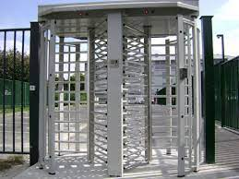  Caption: Sample of an outdoor turnstile gate.
2. | 4 metal doors with reinforced electromagnetic locks:  Metal door, or steel slab door with multi-purpose electromagnetic locks operated with a magnetic card.  Specifications:  - Door material – reinforced steel  - Reinforced hinges and door frame.  - Electromagnetic locks sustaining 750 kg force.  - The doors should be fitted with a card reader allowing restricted access control. | 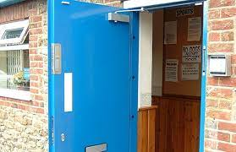  Caption: Reinforced door with a magnetic lock.
3. | 2 metal doors with reinforced hinges and door closers.  The doors should be installed in a reinforced metal frame with 6 -8 points anchorage. | 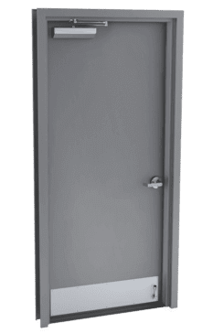  Caption: Commercial rated metal door with a door closer.
4 | Access control system.  •Weatherproof Ethernet biometric terminal (Fingerprint, face recognition and ID card).  •Supply of 150 ID cards  •LCD screen to display time, date, week, user ID, name, and attendance information  •Support registering fingerprints, facial and ID cards from the terminal to the software remotely.  •Ability swiping data and attendance report to USB and/or memory card.  •Complete software solution for attendance and access control management system, with the ability to have more than 5 different profiles that include the followings:  Manage shifts and schedules for staff: to provide with all functionality to manage and record shifts and working hours through a clear streamlines interface.  Easily output monthly timecards and absent reports: Employee monthly timecards, hours worked per profile.  •The service must include installation and configuration of terminals and software. Small training on the system to be given to UNHCR IT staff.  Quantity: 8  (2 for UNHCR staff and visitors, 6 depend on protection needs (Fingerprint or face recognition and ID card))  Face Picture Capacity 3,000 users  Fingerprint Capacity 5,000 users  Card Capacity 5,000 users  Event Capacity 100,000 | 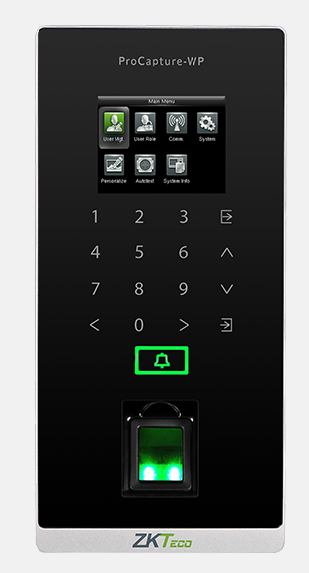
5 | anti-climb fence reinforcement.  113 linear meters of 0.8 m long stakes with 12 cm spacing. | 